**MinimumPrice vs CityMPG:**

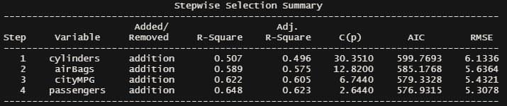

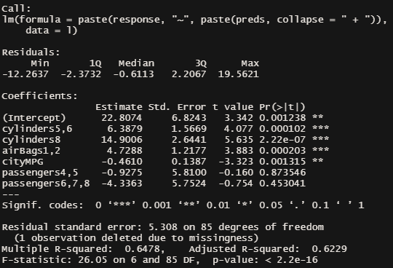 0.65